**Advantage/Disadvantages and Use of TIU Objects contrasted with List of Specific Note Titles method for use in documenting Note entry. This would be Alternative B/ (I combined with Alternative G) as TIU object methods compared to Alternative C which is a List of Titles method:**

Regarding where to place these specialized TIU objects the best place is at a high TIU Template level, even the highest level such as a Group Dialog Template or a Reminder Dialog Template level, since a whole TIU Template can be used in a manual call-up from other Note Titles beyond the Specific Note Titles normally considered, but could be used by some providers in their practice. Even if standard TIU Progress Note Titles might be suggested for use, it allows more capability for using the specialized TIU objects in other ways with other Titles when used with a “manual” selection of Template drawer, “Shared” folder, and then particular Group Dialog or Reminder Dialog TIU Template. Also, it makes it more comprehensive using these specialized TIU objects in this way to contrast with just scanning for a specific smaller list of Progress Note Titles a site wants to screen for site specific Progress Note entry as a method of follow-up action. Specific Progress Note entry also requires an additional lookup and search over a date range to find the Progress Note Title(s) for patients among the list of these select Progress Note Titles listed in a Knowledge database. There is also a possibility of a Specific Note Title being made with a very old Visit date/time being selected for adding a new “Note Entry”. Any V health Factors created for “Note Entry” could be outside range of alert follow-up activities when associated with this Visit (date). This can be a disadvantage for both methods, but a TIU object allows the possibility of Note entry and other associated any V Health factors to be connected with a Historical (Event) type visit as a New visit when the original visit is older and outside the range of Alert tracking. This allows existing AWARE tracking logic to acknowledge that a proper follow-up has been done with “Note Entry” Health factors in a Historical (Event) visit as a New visit as before (See Alternative I). And Alternative B just guarantees successful tracking when original New Visits for “Note Entry” follow-up are made.

**“Note Entry” TIU object placed in particular Progress Note Titles or Progress Note Titles’ associated TIU Template**

For Alternative B with a TIU Object for “Note Entry”, only a New visit entry will allow for allow sure accounting of “Note Entry” follow-up activity. This would not have logic to write into a new created Historical (Event) visit for TIU object. A V Health factor would be written into the selected visit with Note. Documentation of such would be into the “Comments” field of V Health factor with Progress Note Title, Note date/time, and original Visit date (whether it is into selected visit or new Historical (Event) visit).

For Alternative I (with Alternative G) with a TIU Object for “Note Entry”, either a New visit entry or an old Visit entry will allow accounting of “Note Entry” follow-up activity. This would have logic to write into a new created Historical (Event) visit for TIU object when the associated Visit with the Note is a past Visit as well as writing a V Health factor into a New visit with the Note. Documentation of such would be into the “Comments” field of V Health factor.

The AWARE Reminder Dialog for both Alternatives B and I would require an additional Reminder Dialog element (preferably in the Follow-ups Group) with a “Note Entry” Health factor as An Additional Findings value.

A queued background task from the TIU object is needed to generate the “Note Entry” V Health Factor if a Note is made to a new Visit. It will not need to queue this background task if this is a 2nd or latter Note or Addendum to an existing Visit.

Either Alternative B or I require that a new Reminder Dialog element be defined in the associated AWARE Reminder Dialog which has the corresponding same Health Factor in its Additional findings value. This will allow the “Note” entry action from a Specific Progress Note Title or Progress Note Titles’ associated TIU Template to be counted as a Follow-up action. This is through the existing and normal AWARE tracking logic through Reminder Dialog processing.

Alternative I also requires that a similar (but different TIU object) be placed into the associated Alert Type(s)’s Reminder Dialog. This is not the same as the one placed in the specific Progress Note Title or associated TIU Template.

**AWARE Reminder Dialog “Smart Logic”**

With “Smart logic” added to AWARE Reminder Dialog TIU Templates using TIU objects as with Alternative G (and additionally required with Alternative I), a TIU object as described below should be entered into the Template(s). A TIU object similar ( but different than the one described above just a “Note Entry” V Health Factor generation made from certain progress Note Titles or TIU Templates not including the AWARE Reminder Dialog TIU Template(s)). Even if no Reminder Dialog elements are selected, an automatic generation of a “Note Entry” V Health factor entry will be done to count as a follow-up such as AW500 OCC Note Entry as the Health Factor with the FOBT Alert type.

For a New Historical (Event) visit, a “Note Entry” V Health factor is not initially entered into a new created Historical (Event) visit, but instead a V Health factor is written into the selected visit with Note. Documentation of such is made into the “Comments” field of V health factor.

When Note is associated with a Visit which is not a new Visit, then a “Note Entry” V Health factor will subsequently be copied into a new created Historical (Event) visit.

The “Note Entry” V Health factor entry will always have a “Comments field” data with Progress Note Title, Note date/time, and original Visit date (whether it is into selected visit or new Historical (Event) visit).

A V Health factor for a “Note Entry” Health Factor is required in an Additional Findings component of new Reminder Dialog element for such “Note Entry” , with element hidden from view, and not requiring any data entry. The default setting for entering a note entry does not need any check marking for such. Preferably a “Note Entry” Reminder Dialog Element needs to be designed into Follow-ups Reminder Dialog Group (i.e. AVEFA FOBT FOLLOW-UP GROUP)

A queued task needs to be triggered in background from TIU object which runs up to a period say 3 minutes collecting any V Health Factors entered for selected visit, and if new Historical (Event) visit needs to be made (because selected visit is not a new visit), then make the Historical (Event) visit, and check periodically up to more 10 minutes for V Health factors made at selected visit, copying them as found to the new Historical (Event) visit. This includes the “Note Entry” V Health factor as well as other entered Reminder Dialog V Health factors. These copied V health factors will always have a “Comments field” data with Progress Note title and Visit data.

The Alert Cache builder and CPRS AWARE will either use the selected visit’s V health factors (if within Visit range for an Alert) , or a new Historical (Event) visit’s V Health factors when doing an alert follow-up tracking (Alert Cache Builder), or follow-up check for prompting (CPRS AWARE). A new associated Historical (Event) visit will help find follow-up activities with older visits, especially when a selected visit is older in time, and chronologically is dated before the involved Alert’s occurrence.

**Particulars:**

If doing Alternative B then only selected visit V Health factors would be generated for a new “Note Entry” type. This mostly limits the visit to make a “Note Entry” to be a New visit.

If doing Alternative B or I (which is combined with Alternative G), there would be still be a similar ( but different ) “Note Entry” TIU object on a Reminder Dialog ( as when used with Alternative G) from the “Note Entry” one on a Progress Note or top level TIU template (Alternative I).

Historical (Event) visit can be just the current date (w/o time) to be shared by all TIU objects needing to use it. It can be written into from any of the TIU objects (“Note Entry” or individual Reminder Dialog type ones)

Here is V health Factor below for AW500 OCC ENTERED NOTE directly BY TIU OBJECT with a 2ND note with a Visit. See 2nd note as written in the following screen which allows this V Health Factor to directly be generated (since a visit already exist from 1st saved note). If it was 1st note, then a background spawned task from TIU object would have to make this V Health factor.

Select V HEALTH FACTORS: AW500 OCC ENTERED NOTE

HEALTH FACTOR: AW500 OCC ENTERED NOTE PATIENT NAME: FOUR,PATIENT

VISIT: AUG 29, 2015@01:21:48

EVENT DATE AND TIME: AUG 29, 2015@02:09:34

ENCOUNTER PROVIDER: CLINCOORDINATOR,TWO

AUDIT TRAIL: 19-A 10000000087;

COMMENTS: PRIMARY CARE GENERAL NOTE;Aug 29, 2015@01:54;VISIT=Aug 29, 2015@01:21:48 PACKAGE: ORDER ENTRY/RESULTS REPORTING

DATA SOURCE: TEXT INTEGRATION UTILITIES

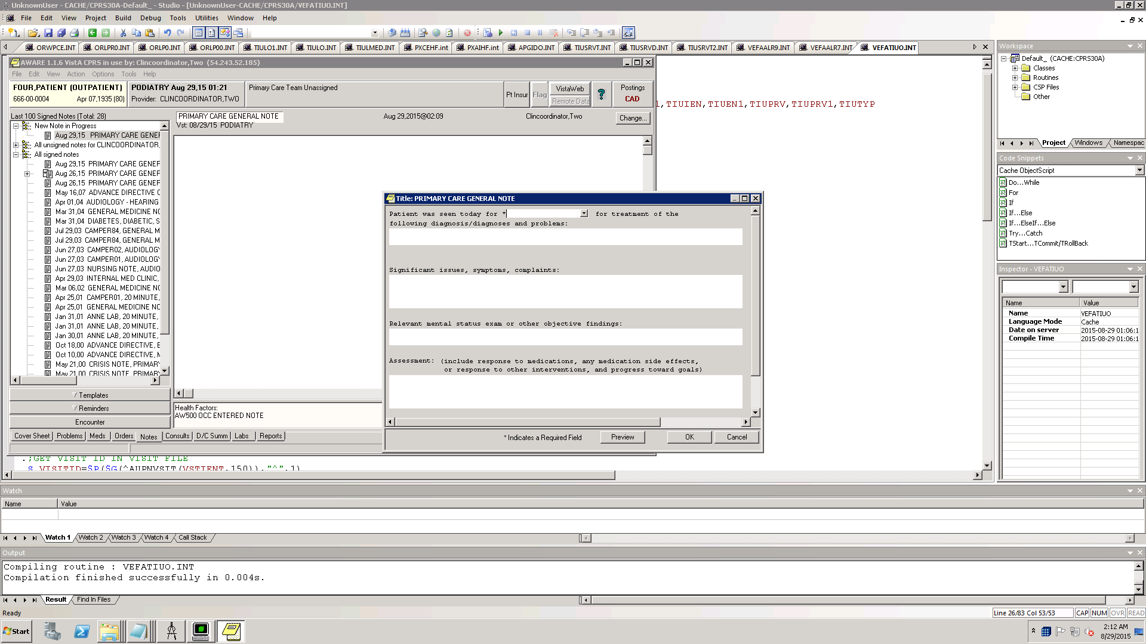

**TIU object placement in FECAL IMMUNOCHEMICAL TESTING (FIT) Results Letter TIU Template with PACT FECAL IMMUNOCHEMICAL TESTING (FIT) RESULTS LETTER Progress Note.**

A “Note Entry” Reminder Dialog Element **"AW500 OCC NOTE ENTRY's** Health Factor **"AW500 OCC NOTE ENTRY"** could possibly be written to the Visit for the Note in terms of a TIU object that is laid onto the **PACT FECAL IMMUNOCHEMICAL TESTING (FIT) RESULTS LETTER** Progress Note title, or onto the "**FECAL IMMUNOCHEMICAL TESTING (FIT) Results Letter**" TIU Template it calls. This TIU template is actually called "**PACT FECAL IMMUNOCHEMICAL TESTING (FIT) Results Letter**" but with the "PACT" removed in the call up. It is a Group Template type not a Reminder Dialog Template type.

Here are the data components:

TIU Document Definitions file

ANOTHER ONE:   
STANDARD CAPTIONED OUTPUT? Yes// (Yes)  
Include COMPUTED fields: (N/Y/R/B): NO// - No record number (IEN), no Computed  
Fields  
DISPLAY AUDIT TRAIL? No// NO

NAME: PACT FECAL IMMUNOCHEMICAL TESTING (FIT) RESULTS LETTER  
PRINT NAME: PACT FECAL IMMUNOCHEMICAL TESTING (FIT) RESULTS LETTER  
TYPE: TITLE CLASS OWNER: CLINICAL COORDINATOR  
STATUS: ACTIVE  
VHA ENTERPRISE STANDARD TITLE: PRIMARY CARE LETTERS  
MAP ATTEMPTED: AUG 10, [2012@11:31:27](mailto:2012@11:31:27)  
MAP ATTEMPTED BY: ROMAN-INGLETON,ELIZABETH  
TIMESTAMP: 62679,49573

Next the TIU Template with TIU Title FECAL IMMUNOCHEMICAL TESTING (FIT) RESULTS LETTER

Inquire to File Entries  
List File Attributes  
Print File Entries  
Search File Entries

Select FM VA FileMan Option: PRINT File Entries

OUTPUT FROM WHAT FILE: TIU TEMPLATE//   
SORT BY: NAME//   
START WITH NAME: FIRST// A  
GO TO NAME: LAST// Z  
WITHIN NAME, SORT BY: LINK=PACT FECAL IMMUNOCHEMICAL TESTING (FIT) RESULTS LER  
??  
WITHIN NAME, SORT BY: LINK   
START WITH LINK: FIRST// PACT FECAL IMMUNOCHEMICAL TESTING (FIT) RESULTS LETTR  
GO TO LINK: LAST// PACT FECAL IMMUNOCHEMICAL TESTING (FIT) RESULTS LETTERZ  
WITHIN LINK, SORT BY:   
STORE IN 'SORT' TEMPLATE:   
FIRST PRINT FIELD: [CAPTIONED   
  
Include COMPUTED fields: (N/Y/R/B): NO// - No record number (IEN), no Computed  
Fields  
DISPLAY AUDIT TRAIL? No// NO  
Heading (S/C): TIU TEMPLATE LIST//   
START AT PAGE: 1//   
DEVICE: HOME (CRT) Right Margin: 80//

...SORRY, HOLD ON...

TIU TEMPLATE LIST AUG 19,2015 15:04 PAGE 1  
--------------------------------------------------------------------------------

NAME: PACT FECAL IMMUNOCHEMICAL TESTING (FIT) RESULTS LETTER   
TYPE: GROUP TEMPLATE STATUS: ACTIVE  
EXCLUDE FROM GROUP BOILERPLATE: NO DIALOG: YES  
DISPLAY ONLY: NO FIRST LINE: NO  
ONE ITEM ONLY: NO HIDE DIALOG ITEMS: NO  
HIDE TREE ITEMS: NO INDENT ITEMS: YES  
LOCK: Not Locked  
LINK: PACT FECAL IMMUNOCHEMICAL TESTING (FIT) RESULTS LETTER **<----- LETTERS type document title**  
BOILERPLATE TEXT:   
Department of Veterans Affairs  
Long Beach Healthcare System  
5901 East Seventh Street  
Long Beach, Ca 90822  
Tel. [(562) 826-8000](tel:%28562%29%20826-8000)  
  
  
|PATIENT NAME FIRST,LAST| **<---- TIU object**  
|VA-WRIISC ADDRESS| **<----- TIU object**

TIU TEMPLATE LIST AUG 19,2015 15:04 PAGE 2  
--------------------------------------------------------------------------------

|AW500 OCC NOTE ENTRY| **<--- a new TIU object could be put here which could be invisible**, but writes a **AW500 OCC NOTE ENTRY**  Health Factor , the same HF which is used by a new **AW500 NOT ENTRY** reminder dialog element in the AWARE Reminder Dialog **AVEFA FOBT-FIT**.  
  
{FLD:DATE DEF TODAY} **<----TIU Template field**  
  
  
Dear |PATIENT NAME FIRST,LAST| **<--- TIU object**  
  
  
DESCRIPTION:   
8.7.12 ER Created for Maryann Child/Primary Care  
10.19.12 ER Indented patient name and address per Dr.Jenkins request.  
10.26.12 ER Lowered the text for better letter display; corrected wording to the  
  
Negative results (grammatical) per Myeasha Kimble request.  
SEQUENCE: 1 ITEM: Results

SEQUENCE: 2 ITEM: Appt. <--- **item 2 with second check box**  
SEQUENCE: 3 ITEM: Sincerely <----- **item 3 with third check box**

Press RETURN to continue...

https://ssl.gstatic.com/ui/v1/icons/mail/images/cleardot.gif

Note, the Letter Note is reporting both "Negative' and "Positive" results. However, AWARE reports only on Positive” results, and only on Alerts with “Positive” results**.** So the Letter Note made with “Positive” results can resolve follow-up status done for AWARE alerts. There will be no AWARE alerts for “Negative” results so the actions taken for “Note Entry” taken for “Negative” would be ignored with any AWARE processing.

**Instructions to Add new element “AW500 OCC NOTE ENTRY “ into the “AVEFA FOBT FOLLOW-UP GROUP” Reminder Dialog Group with “AW500 OCC NOTE ENTRY” Health Factor as an Additional Finding**

First create a Health factor “AW500 OCC NOTE ENTRY”.

Then add the NEW element “AW500 OCC NOTE ENTRY” into the AVEFA FOBT-FIT Reminder Dialog:

D ^XQ1

Select OPTION NAME: PXRM DIAL

1 PXRM DIALOG CHECKER Check Reminder Dialog for invalid items

2 PXRM DIALOG CHECKER ALL Check all active reminder dialog for invalid items

3 PXRM DIALOG EMPTY REPORT Empty Reminder Dialog Report

4 PXRM DIALOG MANAGEMENT Reminder Dialog Management

5 PXRM DIALOG ORPHAN REPORT Reminder Dialog Elements Orphan Report

Press <RETURN> to see more, '^' to exit this list, OR

CHOOSE 1-5: 4 PXRM DIALOG MANAGEMENT Reminder Dialog Management

DP Dialog Parameters ...

DI Reminder Dialogs

DR Dialog Reports ...

IA Inactive Codes Mail Message

You have PENDING ALERTS

Enter "VA to jump to VIEW ALERTS option

Select Reminder Dialog Management <TEST ACCOUNT> Option: DI Reminder Dialogs

Dialog List Sep 01, 2015@14:06:26 Page: 1 of 14

REMINDER VIEW (ALL REMINDERS BY NAME)

Item Reminder Name Linked Dialog Name & Dialog Status

1 ARD 00 ANTICOAGULATION AFIB

2 BL PCLC NEEDED

3 BL PHQ9 NEEDED UPDATE PHQ2 INFO TEXT Disabled

4 BL SUICIDE RISK NEEDED

5 CHF OUTPATIENT EDUCATION

6 CRD 00 ANTICOAG FOR AFIB

7 CRD ANTICOAG FOR AFIB

8 DIABETES - RETINAL EXAM PH DIABETIC RETINAL EXAM

9 DIABETES CREATININE

10 DIABETES HBA1C

11 DIABETES URINALYSIS

12 EVALUATION OF + DEPRESSION SCREEN EVALUATION OF + DEPRESSION Disabled

13 EVALUATION OF + PTSD SCREEN EVALUATION OF + PTSD SCREEN Disabled

14 HEP C - DZ & TRANSMISSION EDUCATIO

+ Enter ?? for more actions >>>

AR All reminders LR Linked Reminders QU Quit

CV Change View RN Name/Print Name

Select Item: Next Screen//CV

R Reminders

RG Result Group (Mental Health)

RE Result Element (Mental Health)

TYPE OF VIEW: R// D

Dialog List Sep 01, 2015@14:08:15 Page: 1 of 6

DIALOG VIEW (REMINDER DIALOGS - SOURCE REMINDER NAME)

Item Reminder Dialog Name Source Reminder Status

1 ARD 227H ANTICOAGULATION FOR AFIB ARD 00 ANTICOAGULATION AF

2 AVEFA ABNORMAL CXR *NONE*

3 AVEFA ABNORMAL MAMMOGRAM *NONE*

4 AVEFA FOBT-FIT *NONE*

5 AVEFA PSA *NONE*

6 CRD ANTICOAG AFIB/FLUTTER ARD 00 ANTICOAGULATION AF

7 EMPLOYEE PPD - >13MONTHS *NONE*

8 EVALUATION OF + DEPRESSION SCREEN EVALUATION OF + DEPRESSIO Disabled

9 EVALUATION OF + PTSD SCREEN EVALUATION OF + PTSD SCRE Disabled

10 HEP C - EVALUATION FOR TREATMENT HEP C - EVALUATION FOR TR Linked

11 HEP C RISK FACTOR SCREENING HEP C RISK FACTOR SCREENI Linked

12 HEP C TESTING FOR AT RISK PT HEP C TESTING FOR AT RISK Linked

13 HIV RPR *NONE* Disabled

14 HTN AND BP>140 OR >90 HTN AND BP>140 OR >90 Linked

+ + Next Screen - Prev Screen ?? More Actions >>>

AD Add Reminder Dialog PT List/Print All QU Quit

CV Change View RN Name/Print Name

Select Item: Next Screen//4

Dialog Edit List Sep 01, 2015@14:09:07 Page: 1 of 2

REMINDER DIALOG NAME: AVEFA FOBT-FIT

Item Seq. Dialog Summary

1 1 Group: AVEFA FOBT ORDERS GROUP

2 1.1 Element: AW500 OCC FOBT REPEAT FOBT

3 1.2 Element: AW500 OCC FOBT ORDER CBC WITH DIFF

4 1.3 Element: AW500 OCC FOBT ORDER GI CONSULT

5 1.4 Element: AW500 OCC FOBT ORDER COLONOSCOPY

6 1.5 Element: AW500 OCC FOBT COLRECTAL SURGERY REFERRAL

7 2 Group: AVEFA FOBT FOLLOW-UP GROUP

8 2.1 Element: AW500 OCC DISCUSSED WITH PAT

+ + Next Screen - Prev Screen ?? More Actions >>>

ADD Add Element/Group DS Dialog Summary INQ Inquiry/Print

CO Copy Dialog DO Dialog Overview QU Quit

DD Detailed Display DT Dialog Text

DP Progress Note Text ED Edit/Delete Dialog

Select Item: Next Screen//

Dialog Edit List Sep 01, 2015@14:11:15 Page: 2 of 2

REMINDER DIALOG NAME: AVEFA FOBT-FIT

+Item Seq. Dialog Summary

9 2.2 Element: AW500 OCC REFER TO ANOTHER VA PROV

10 2.3 Element: AW500 OCC FOLLOWUP

11 2.4 Element: AW500 OCC LIMITED LIFE

12 2.5 Element: AW500 OCC PAT NO LONGER IN CARE

13 2.6 Element: AW500 OCC PAT OPTED NO TREAT

14 3 Group: AVEFA FOBT FOLLOWUP COMMENTS GROUP

15 3.1 Element: AW500 OCC OTHER FOLLOWUP COMMENTS

+ Next Screen - Prev Screen ?? More Actions >>>

ADD Add Element/Group DS Dialog Summary INQ Inquiry/Print

CO Copy Dialog DO Dialog Overview QU Quit

DD Detailed Display DT Dialog Text

DP Progress Note Text ED Edit/Delete Dialog

Select Item: Quit// ADD Add Element/Group

Enter a new SEQUENCE NUMBER: 2.7

Add sequence 7 to group AVEFA FOBT FOLLOW-UP GROUP: N// YES

Select new DIALOG ELEMENT: AW500 OCC NOTE ENTRY

Are you adding 'AW500 OCC NOTE ENTRY' as

a new REMINDER DIALOG? No// Y (Yes)

NAME: AW500 OCC NOTE ENTRY Replace

DISABLE:

CLASS:

Choose from:

N NATIONAL

V VISN

L LOCAL

CLASS: L LOCAL

SPONSOR:

REVIEW DATE:

RESOLUTION TYPE:

ORDERABLE ITEM:

FINDING ITEM:

Select ADDITIONAL FINDING: AW500 OCC NOTE ENTRY

ADDITIONAL FINDINGS: AW500 OCC NOTE ENTRY//

Additional findings:

HF AW500 OCC NOTE ENTRY Finding # 1

Select ADDITIONAL FINDING:

DIALOG/PROGRESS NOTE TEXT:

No existing text

Edit? NO//

ALTERNATE PROGRESS NOTE TEXT:

No existing text

Edit? NO//

EXCLUDE FROM PROGRESS NOTE:

SUPPRESS CHECKBOX: Y

Enter 1 if the WP text is for display only.

Choose from:

1 SUPPRESS

SUPPRESS CHECKBOX: 1

Select SEQUENCE:

REMINDER TERM:

Input your edit comments.

Edit? NO//

Dialog Edit List Sep 01, 2015@14:23:23 Page: 2 of 3

REMINDER DIALOG NAME: AVEFA FOBT-FIT

+Item Seq. Dialog Summary

9 2.2 Element: AW500 OCC REFER TO ANOTHER VA PROV

10 2.3 Element: AW500 OCC FOLLOWUP

11 2.4 Element: AW500 OCC LIMITED LIFE

12 2.5 Element: AW500 OCC PAT NO LONGER IN CARE

13 2.6 Element: AW500 OCC PAT OPTED NO TREAT

14 2.7 Element: AW500 OCC NOTE ENTRY

15 3 Group: AVEFA FOBT FOLLOWUP COMMENTS GROUP

+ + Next Screen - Prev Screen ?? More Actions >>>

ADD Add Element/Group DS Dialog Summary INQ Inquiry/Print

CO Copy Dialog DO Dialog Overview QU Quit

DD Detailed Display DT Dialog Text

DP Progress Note Text ED Edit/Delete Dialog

Select Item: Next Screen//Q

Dialog List Sep 01, 2015@14:24 Page: 1 of 6

DIALOG VIEW (REMINDER DIALOGS - SOURCE REMINDER NAME)

Item Reminder Dialog Name Source Reminder Status

1 ARD 227H ANTICOAGULATION FOR AFIB ARD 00 ANTICOAGULATION AF

2 AVEFA ABNORMAL CXR *NONE*

3 AVEFA ABNORMAL MAMMOGRAM *NONE*

4 AVEFA FOBT-FIT *NONE*

5 AVEFA PSA *NONE*

6 CRD ANTICOAG AFIB/FLUTTER ARD 00 ANTICOAGULATION AF

7 EMPLOYEE PPD - >13MONTHS *NONE*

8 EVALUATION OF + DEPRESSION SCREEN EVALUATION OF + DEPRESSIO Disabled

9 EVALUATION OF + PTSD SCREEN EVALUATION OF + PTSD SCRE Disabled

10 HEP C - EVALUATION FOR TREATMENT HEP C - EVALUATION FOR TR Linked

11 HEP C RISK FACTOR SCREENING HEP C RISK FACTOR SCREENI Linked

12 HEP C TESTING FOR AT RISK PT HEP C TESTING FOR AT RISK Linked

13 HIV RPR *NONE* Disabled

14 HTN AND BP>140 OR >90 HTN AND BP>140 OR >90 Linked

+ Enter ?? for more actions >>>

AD Add Reminder Dialog PT List/Print All QU Quit

CV Change View RN Name/Print Name

Select Item: Next Screen// Quit

DP Dialog Parameters ...

DI Reminder Dialogs

DR Dialog Reports ...

IA Inactive Codes Mail Message

Select Reminder Dialog Management <TEST ACCOUNT> Option:

**Reminder Dialog** below with suppressed “Note Entry” (“**AW500 OCC NOTE ENTRY”)** element with an **“AW500 OCC NOTE ENTRY”** HF. Still will allow to account for a “Note Entered” **“AW500 OCC NOTE ENTRY”** HF made elsewhere from another Note (like from a **“FECAL IMMUNOASSAY (FIT) LETTER” note).**

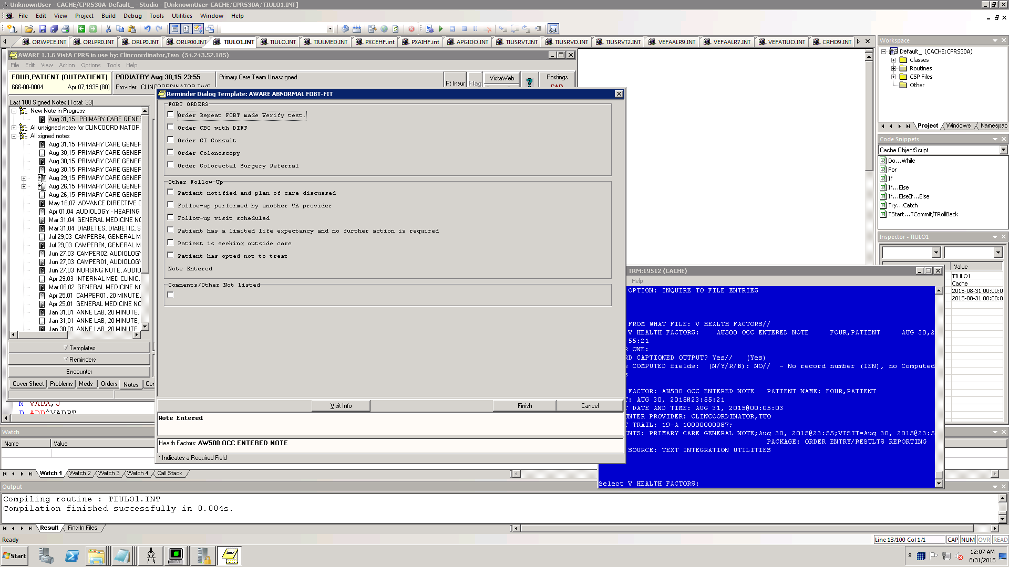

**Instructions to Make a TIU object:**

PRS30A 223d11>D ^XQ1

Select OPTION NAME: TIUFJ CREATE OBJECTS MGR Create Objects

Create Objects

START DISPLAY WITH OBJECT: FIRST// ................................................................................

................................................................................

................................................................................

................................................................................

................................................................................

................................................................................

................................................................................

..............................................

Objects Aug 30, 2015@23:34 Page: 1 of 22

Objects

Status

1 ABG A

2 ACTIVE INPATIENT MEDS A

3 ACTIVE MEDICATIONS A

4 ACTIVE MEDICATIONS BOSTON A

5 ACTIVE MEDS (OP,IV,UD);2 A

6 ACTIVE MEDS (OP,IV,UD);45 A

7 ACTIVE MEDS COMBINED A

8 ACTIVE OP MEDS;45 A

9 ACTIVE/PENDING/EXPIRED MEDICATIONS A

10 ACTIVE/PENDING/EXPIRED MEDICATIONS (W/O SUPPLIES) A

11 ADDICTION SEVERITY INDEX A

12 ADMISSION DIAGNOSIS A

13 AFB SMEAR A

14 ALBUMIN A

+ ?Help >ScrollRight PS/PL PrintScrn/List +/- >>>

Find Detailed Display/Edit Copy/Move

Change View Try Quit

Create Owner

SSelect Action: Next Screen// CREATE Create

Enter the Name of a new Object: AW500 OCC NOTE ENTRY

CLASS OWNER: CLINICAL COORDINATOR// CLINICAL COORDINATOR

Entry added

Objects Aug 30, 2015@23:35:07 Page: 2 of 22

Objects

+ Status

26 AW500 OCC NOTE ENTRY I

27 B12 A

28 BANDS A

29 BASIC METABOLIC PANEL A

30 BILIRUBIN, DIRECT A

31 BILIRUBIN, TOTAL A

32 BLOOD PRESSURE A

33 BMI A

34 BRADEN SCALE 30D A

35 BSA A

36 BUN A

37 C-REACTIVE PROTEIN A

38 CALCIUM A

39 CBC & DIFF A

+ ?Help >ScrollRight PS/PL PrintScrn/List +/- >>>

Find Detailed Display/Edit Copy/Move

Change View Try Quit

Create Owner

+ ?Help >ScrollRight PS/PL PrintScrn/List +/- >>>

Find Detailed Display/Edit Copy/Move

Change View Try Quit

Create Owner

Select Action: Next Screen// DET Detailed Display/Edit

Select Entry: (26-39): 26

Detailed Display Aug 30, 2015@23:36:17 Page: 1 of 1

Object AW500 OCC NOTE ENTRY

Basics

Name: AW500 OCC NOTE ENTRY

VHA Enterprise

Standard Title:

Abbreviation:

Print Name: AW500 OCC NOTE ENTRY

Type: OBJECT

IFN: 67

National

Standard: NO

Status: INACTIVE

Owner: CLINICAL COORDINATOR

Technical Fields

Object Method:

? Help +, - Next, Previous Screen PS/PL

Basics Try Delete

Technical Fields Find Quit

Select Action: Quit// TECH Technical Fields

OBJECT METHOD: S X=$$OCCNOTE^VEFATIUO(.TIU,DFN)

etailed Display Aug 30, 2015@23:38:49 Page: 1 of 1

Object AW500 OCC NOTE ENTRY

Basics

Name: AW500 OCC NOTE ENTRY

VHA Enterprise

Standard Title:

Abbreviation:

Print Name: AW500 OCC NOTE ENTRY

Type: OBJECT

IFN: 67

National

Standard: NO

Status: INACTIVE

Owner: CLINICAL COORDINATOR

Technical Fields

Object Method: S X=$$OCCNOTE^VEFATIUO(.TIU,DFN)

? Help +, - Next, Previous Screen PS/PL

Basics Try Delete

Technical Fields Find Quit

Select Action: Quit// BASIC Basics

NAME: AW500 OCC NOTE ENTRY Replace

ABBREVIATION:

PRINT NAME: AW500 OCC NOTE ENTRY Replace

CLASS OWNER: CLINICAL COORDINATOR// CLINICAL COORDINATOR

STATUS: (A/I): INACTIVE// A

Detailed Display Aug 30, 2015@23:39:57 Page: 1 of 1

Object AW500 OCC NOTE ENTRY

Basics

Name: AW500 OCC NOTE ENTRY

VHA Enterprise

Standard Title:

Abbreviation:

Print Name: AW500 OCC NOTE ENTRY

Type: OBJECT

IFN: 67

National

Standard: NO

Status: ACTIVE

Owner: CLINICAL COORDINATOR

Technical Fields

Object Method: S X=$$OCCNOTE^VEFATIUO(.TIU,DFN)

? Help +, - Next, Previous Screen PS/PL

Basics Try Delete

Technical Fields Find Quit

Select Action: Quit//Q

Objects Aug 30, 2015@23:41:26 Page: 2 of 22

Objects

+ Status

26 AW500 OCC NOTE ENTRY A

27 B12 A

28 BANDS A

29 BASIC METABOLIC PANEL A

30 BILIRUBIN, DIRECT A

31 BILIRUBIN, TOTAL A

32 BLOOD PRESSURE A

33 BMI A

34 BRADEN SCALE 30D A

35 BSA A

36 BUN A

37 C-REACTIVE PROTEIN A

38 CALCIUM A

39 CBC & DIFF A

+ ?Help >ScrollRight PS/PL PrintScrn/List +/- >>>

Find Detailed Display/Edit Copy/Move

Change View Try Quit

Create Owner

Select Action: Next Screen// Q